Click the web link:https://fbas2022.scimeeting.cn/en/web, enter the page as shown in the following figure.
There is a “login/register” button in the upper right corner of the page.

Click the “login/register” button to enter the registration page
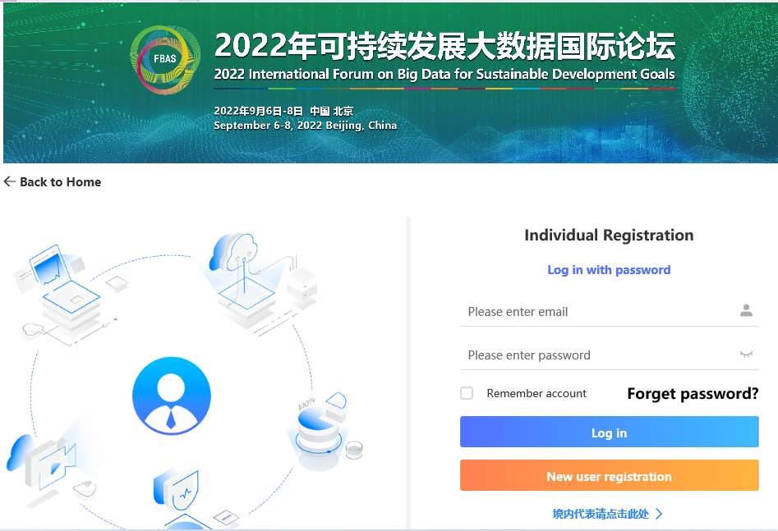

Click the “New user registration” button to enter the page to fill in the registration information,as shown in the following figure.
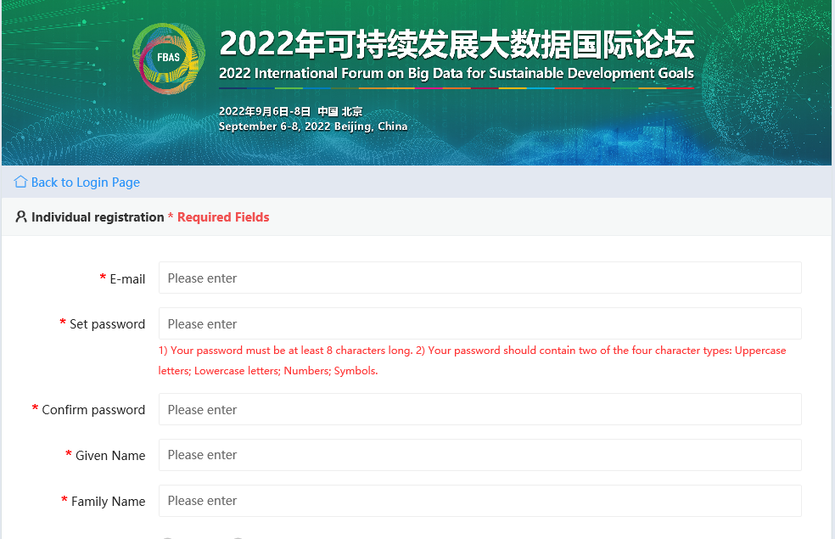
After filling in the registration information, click the “Submit” button to complete the registration.

